Civil war in Liberia

UNSC Resolution: | 1100
Date of adoption: | 27 March 1997
Operative paragraph: | 3
Demand number: | 1100.0311

Sarah-Myriam Martin-Brûlé

Wording of demand
install the new independent Elections Commission and reconstituted Supreme Court immediately

**Wording seems different in the resolution which reads as follow:
“3. Expresses its concern at the delay in the installation of the new independent Elections Commission and the reconstituted Supreme Court, and the implications of this delay for the electoral process, and urges that they be installed immediately;****”

List of addressees of the demand
The government of Liberia

Short-term compliance

Description of the addressee(s)’ conduct

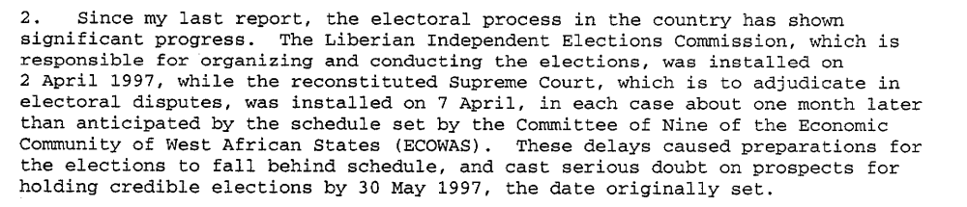

Report of the Secretary General, 19 June 1997, S/1997/478

Assessment

Short-term compliance
No or marginal compliance (1) | Medium low compliance (2) | Medium high compliance (3) | X Full or almost full compliance (4)

Considerations underlying the assessment

The demand addressee almost fully complied with the demand for the Electoral Commission and the Supreme Court were installed one month behind schedule.

Medium-term compliance

Description of the addressee(s)’ conduct

Report of the Secretary General, 19 June 1997, S/1997/478

Assessment

Medium-term compliance
No or marginal compliance (1) | Medium low compliance (2) | Medium high compliance (3) | X Full or almost full compliance (4)

Considerations underlying the assessment
The demand addressee almost fully complied with the demand for the Electoral Commission and the Supreme Court were installed one month behind schedule.

Depth of demand

Assessment

Level of depth of demand
X Low depth of demand (1) | Medium depth of demand (2) | High depth of demand (3)

Considerations underlying the assessment

Compliance with this demand did not represent a risk for the demand addressee.
According to Adebajo (2002) “By 1997 (…)The most powerful, Charles Taylor, was confident of winning power through elections.” (Adebajo 2002: 66)

Adekeye Adebajo. 2002. Building Peace in West Africa: Liberia, Sierra Leone, and Guinea-Bissau. Lynne Rienner. P. 66

Level of confidence about coding decisions

Level of confidence about coding decision
X Extremely high | High | Moderate

Comments to IPI (if any)

